THE LIVER GROUP CHARITY
CHAIRMAN’S STATEMENT 2020

It would be an understatement to say that the past year hasn’t been one of the most challenging on record: for individuals and their loved ones of course – but also for the healthcare and charity sectors. We inhabit both.
So despite the staff shortages, issues with furlough, problems with supply chains, shut labs, and very little face to face contact, it is all the more remarkable that Clare and her team were able to achieve so much in the period.
On the technical side, so much progress has been made on the now trademarked HepatiCan ™. Disposable elements have been designed, finalised and prototypes produced, tested and refined. A technical dossier is being built for regulatory purposes with improved cryopreservation protocols. Stability of the hydrogel and viability of the production of enough viable cells in the biomass, cryopreservable and with the ability to recover function within a timeframe suitable for clinical use are significant steps forward on the technical roadmap.
Since the end of the year further work has been done, including testing the whole system with cryo-recovered biomass in human plasma for 72 hours, establishing and implementing changes to the graphical user interface and exploring ease of use issues for nurses.
With the next stage of the HepatiCan ™ story likely to involve more contact and interaction with the commercial world, we shall work hard to ensure that any conflicts of interest are managed, and that the Charity gains its fair return for the work and money it has expended, thus allowing it to continue its mission of supporting research and development in the liver space.
Clare has been assisted by an able team, and thanks must go to Elizaveta Zotova for her tireless administrative assistance as well as Maya Piri, a UCL student volunteer who has regularly written social media posts for us, even after finishing the degree. Our thanks also go to the UCL scientific team, in particular this year, Eloy Erro, Tom Brookshaw, Sweta Chandel, Sherri Chalmers and Elizaveta Zotova.
Finally, on the fundraising side I am pleased to say that despite the aforementioned difficulties, we raised £31,324 in donations for the year, with special thanks going to Kay Glendinning for a significant donation. There were also excellent contributions through Facebook and sponsorship of participants in the Vitality Half Marathon.
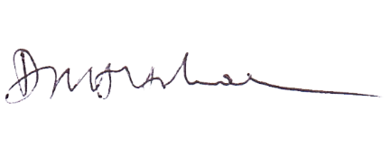
Dr. David Holbrook
Chairman

